# **vSphere Clean up procedure:**

1. Log in to vCenter server using FLEX client.

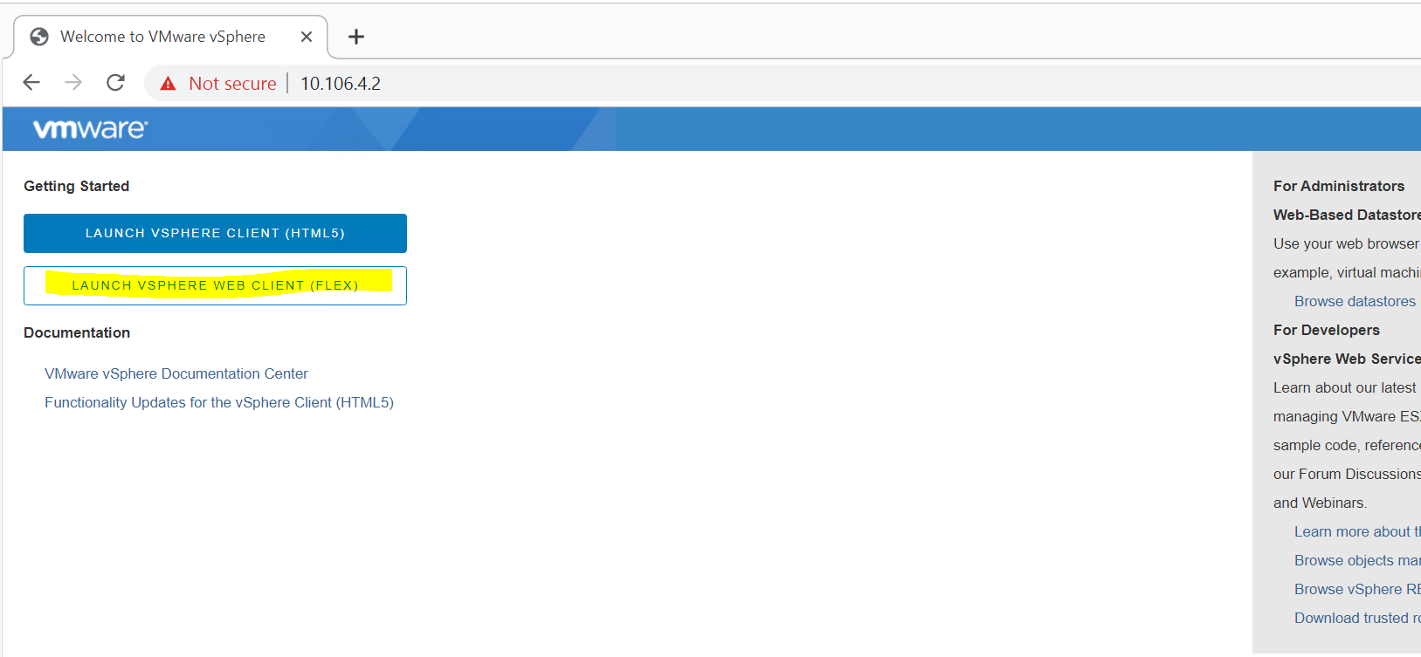

1. Change “Automatic” disk selection to “manual” in vSAN configuration:

Navigate to cluster_name(mgmt_pod)>>configure>>vSAN>>General>>Edit

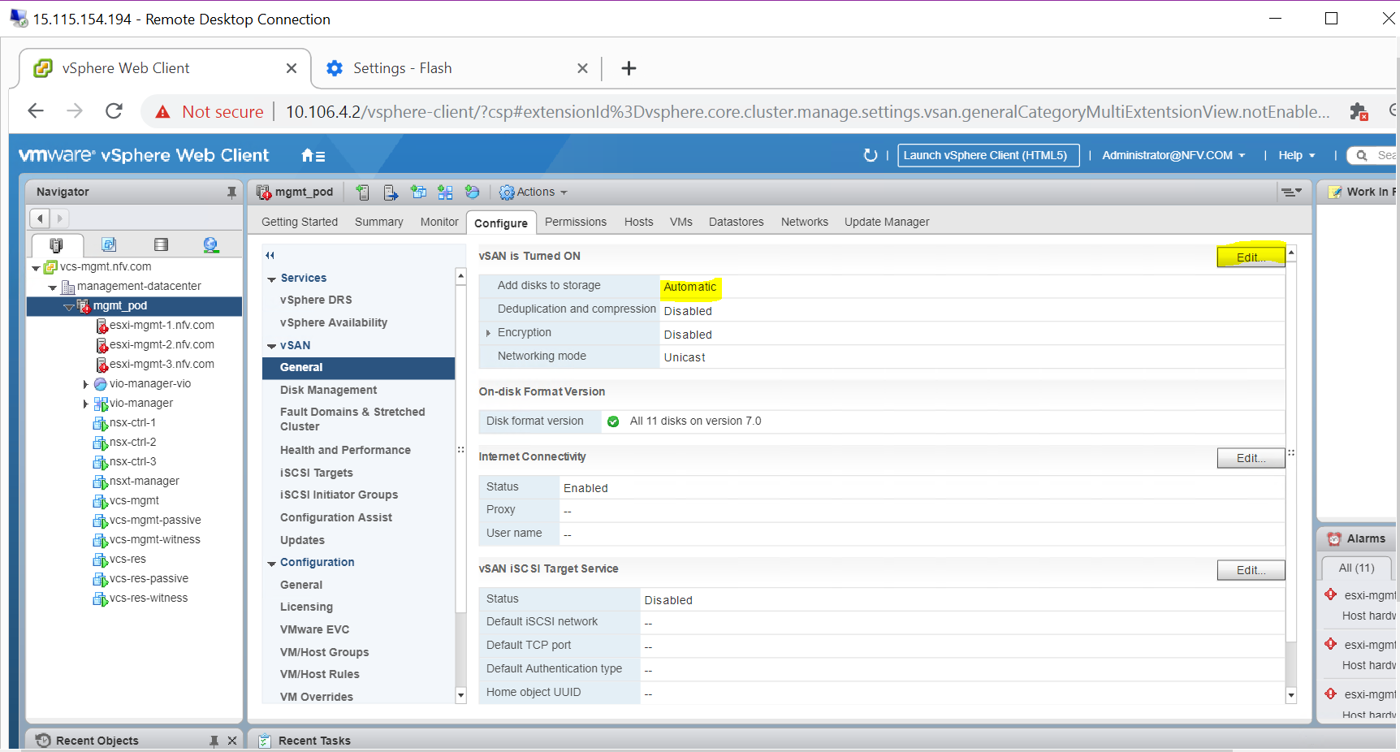

1. From drop down menu, select manual and click OK. Wait for configuration changes to take place.

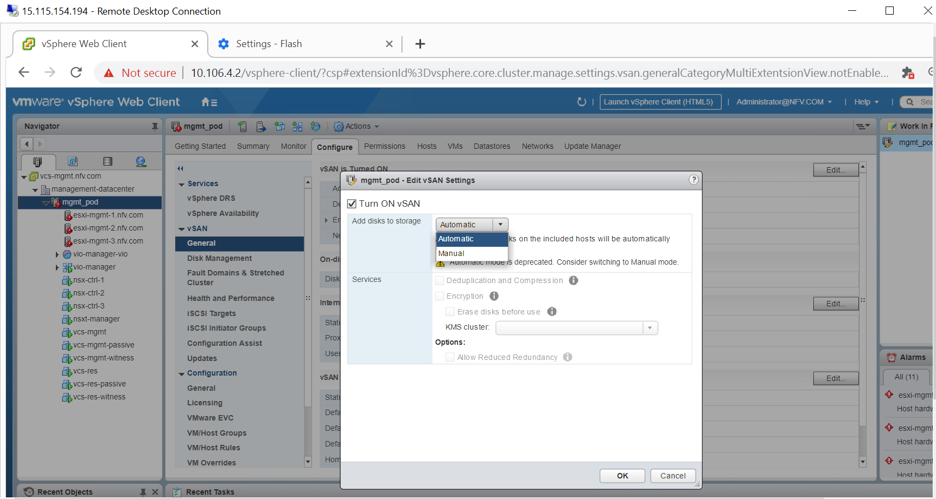

1. Once set to manual navigate to “Disk Management”.

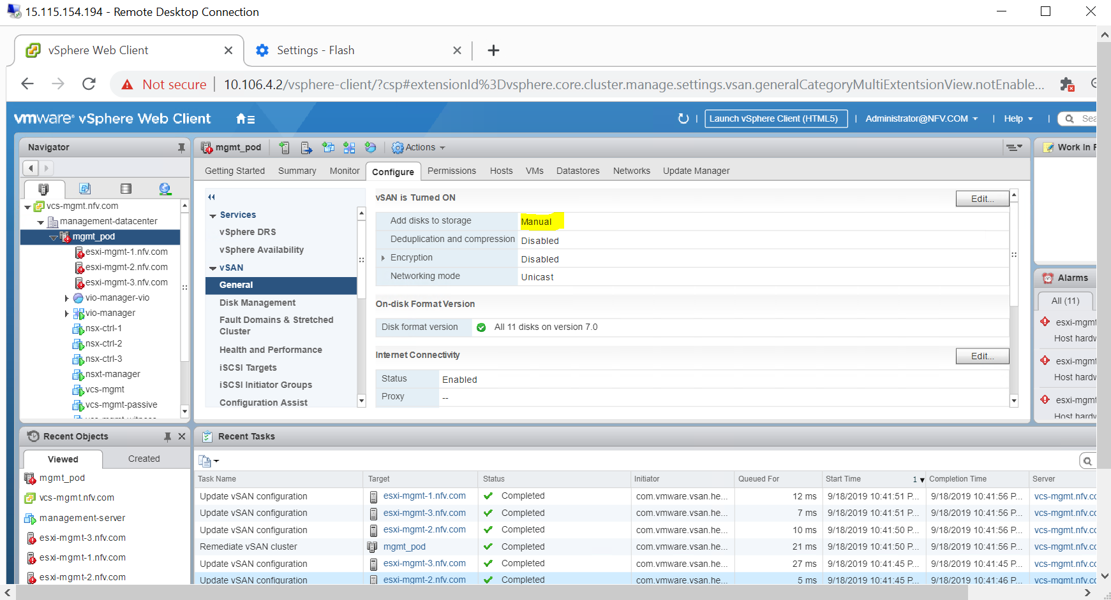

1. From “Disk Management”, select “Disk group” and hit remove disk button as shown in snap.

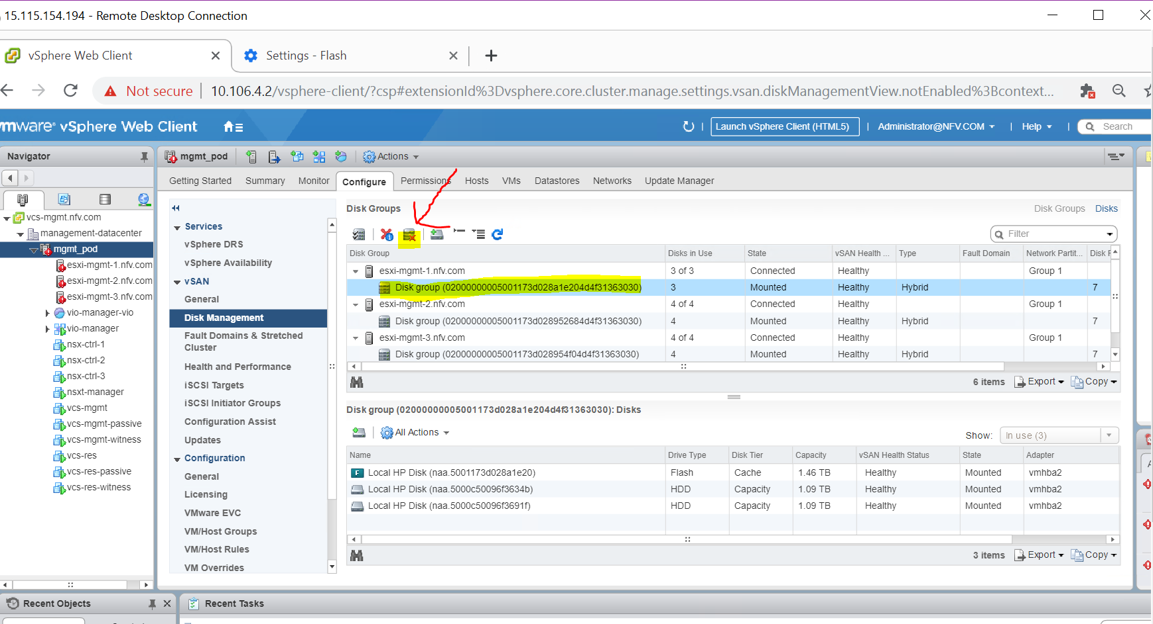

1. Select ‘No data evacuation’ and click ‘yes’. Repeat step 5 and 6 for each disk groups.

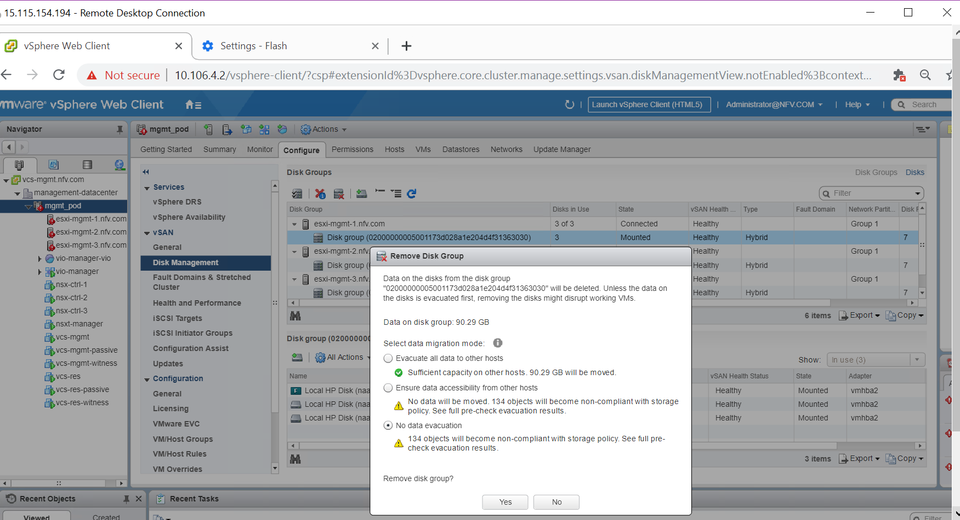

1. After all disk groups are removed, turn off vSAN. And click OK.

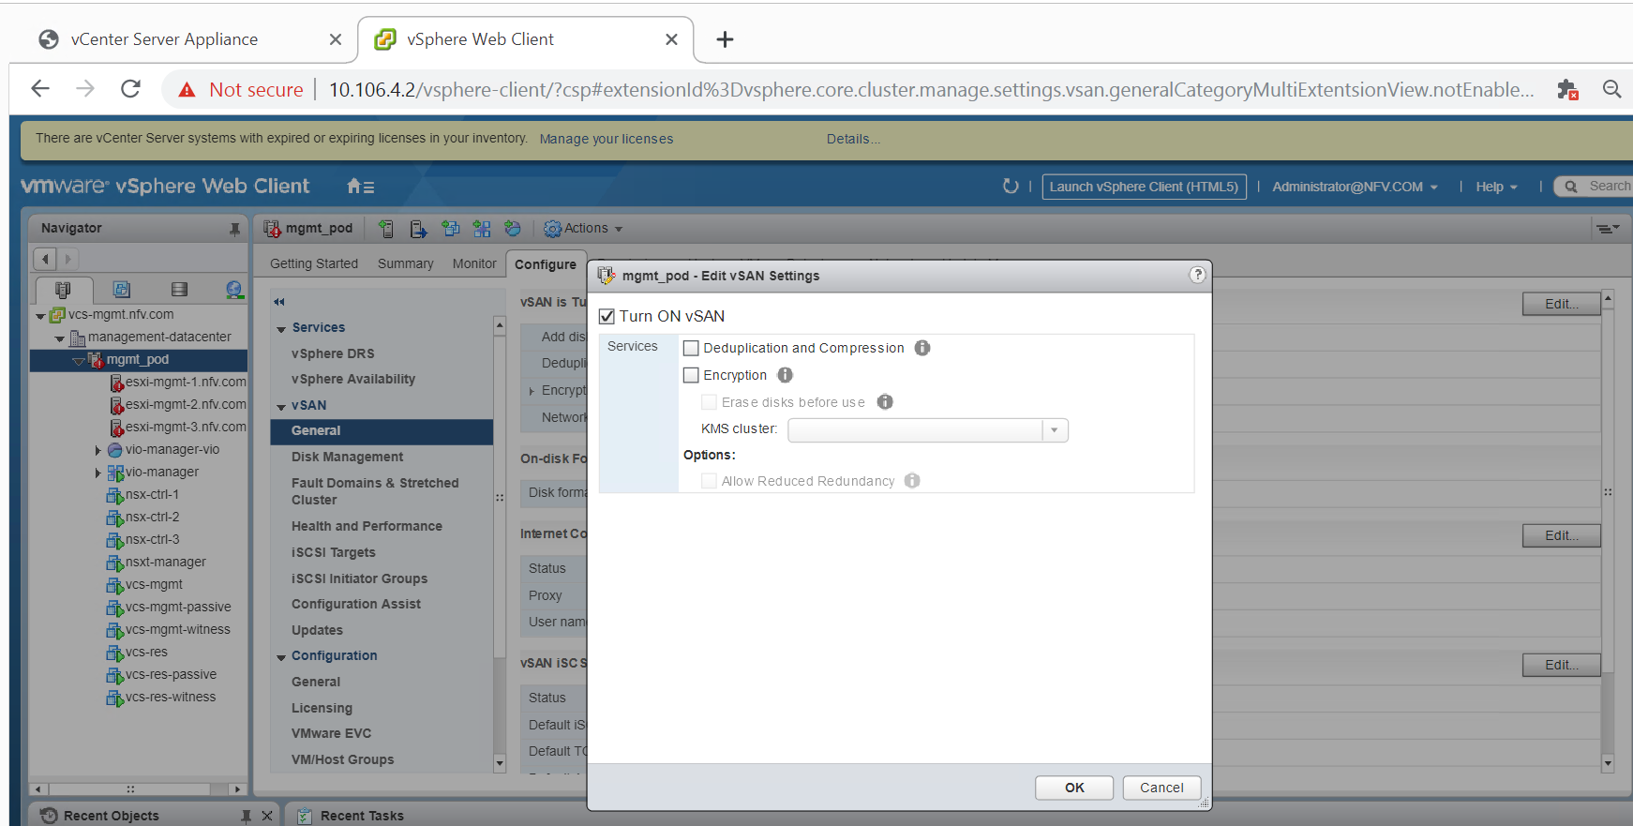

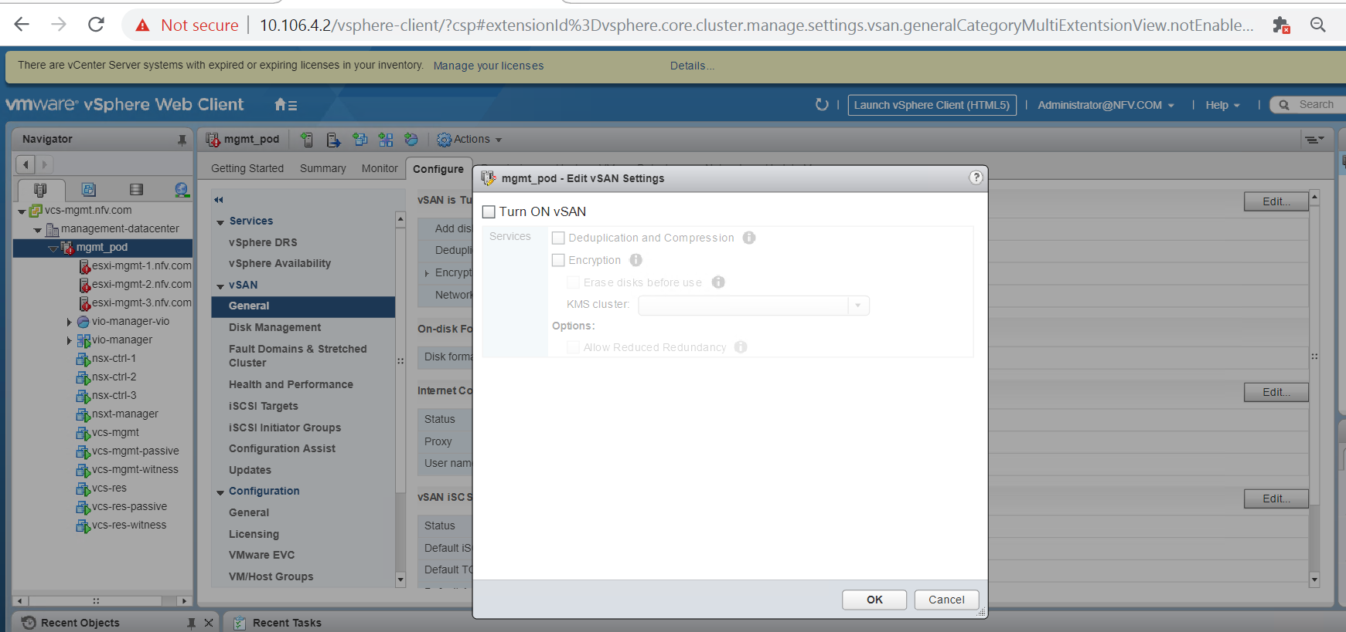

1. Turn off vSphere DRS.

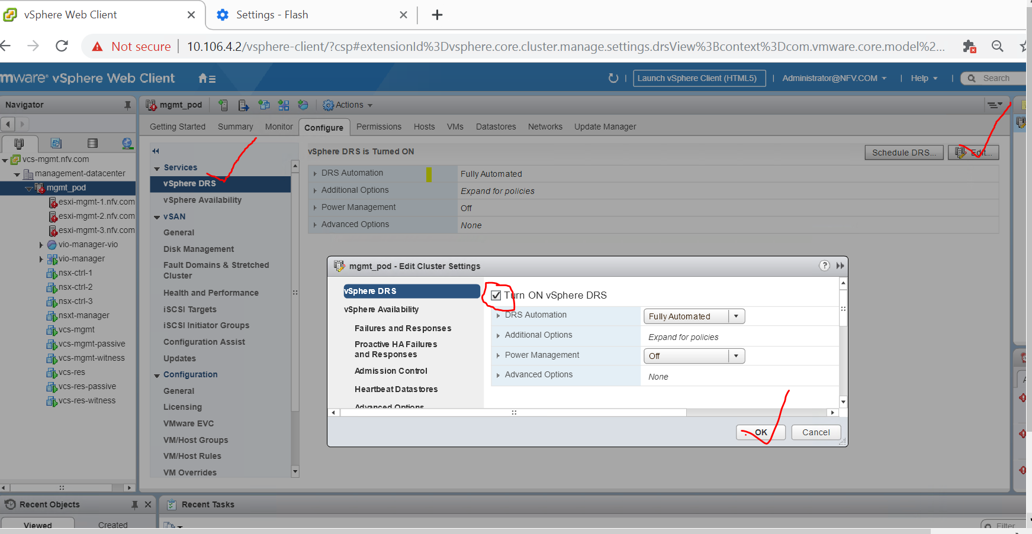

1. Turn off vSphere HA.

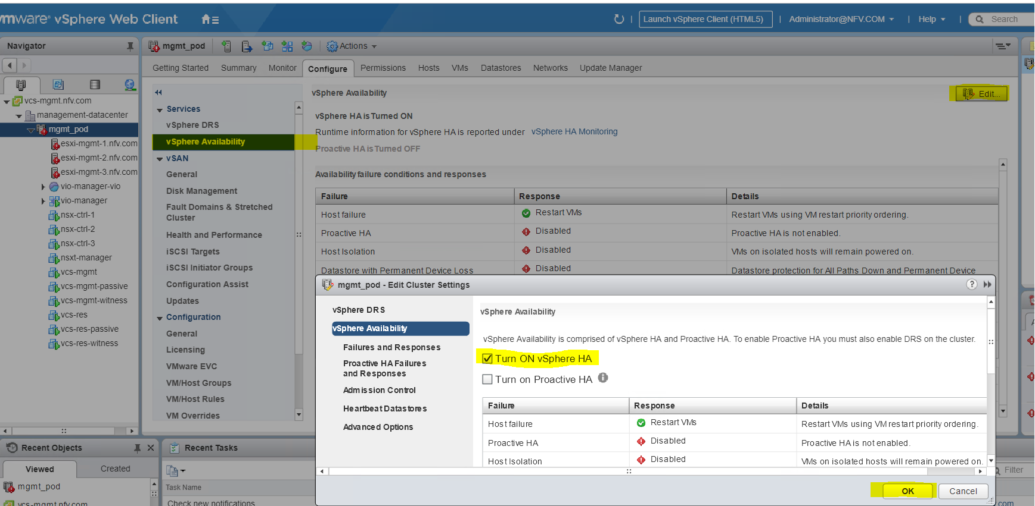

1. Remove DVS networking setting:
   1. DVS networking can be removed by re-installing ESXI OS
   2. By restoring network setting.

Restore network setting:

Log in to iLO IRC and select “Network Restore Options” to clean up networkings. After this operation, management IP, DNS etc has to be done manually.

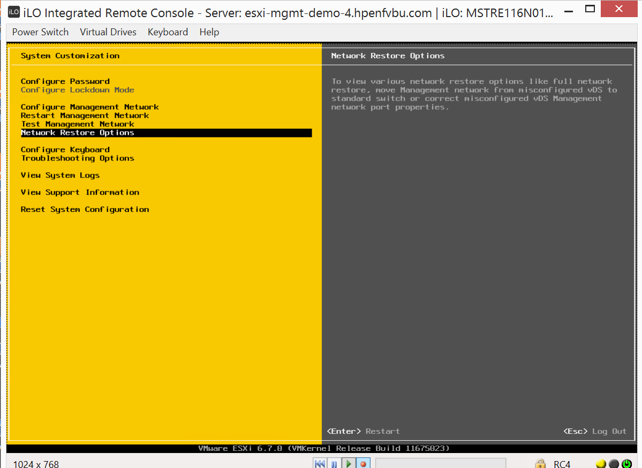

# Special case:

For some reason, if vCenter server is removed from ESXI, below procedure to be followed to clean up vSAN partitions.

Log in to each ESXI servers and perform following:

esxcli vsan cluster leave

for disk in $(esxcli vsan storage list | grep "Device:" | awk '{print $2}'); do for i in 1 2 3 4 5 6; do partedUtil delete /dev/disks/$disk $i;done;done

step2: if you get "read only" related error

-------------------------------------------

esxcli vsan storage list | grep "VSAN Disk Group UUID:" | tail -1 | awk '{print $5}' | xargs esxcli vsan storage remove -u